Micro Controller Unit

The Micro Controller Unit (MCU) is the “brains” of the handset. It is installed in the front cover so that the LCD monitor faces out.

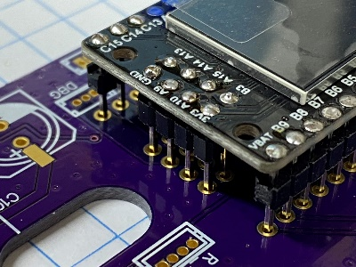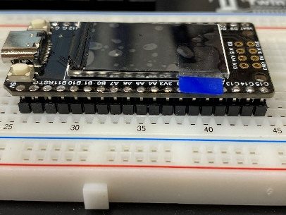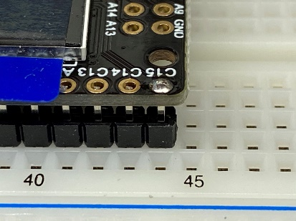 The MCU’s PCB need to sit as close as possible to the indentation in the case so that the LCD is readable after assembly. To accomplish this, you need to solder the header pins with as little sticking out the top as possible. The easiest way that we found was to utilize a solderless breadboard to hold the header pins until you get the MCU soldered in place.

Once the side header pins are soldered in place, use the Main PCB to locate and hold the 2 x 4 header pins in place for final soldering.